Name: Kris Kleiner
Date: April 5, 2026
Assignment: Module 2.2

For this assignment, I used my Miles to Kilometers conversion program. The program prompts the user for input, validates the input, and then calls a function to perform the conversion and display the result. I used the debugger to step through the program and better understand how the data flows through each function.
Screenshot #1
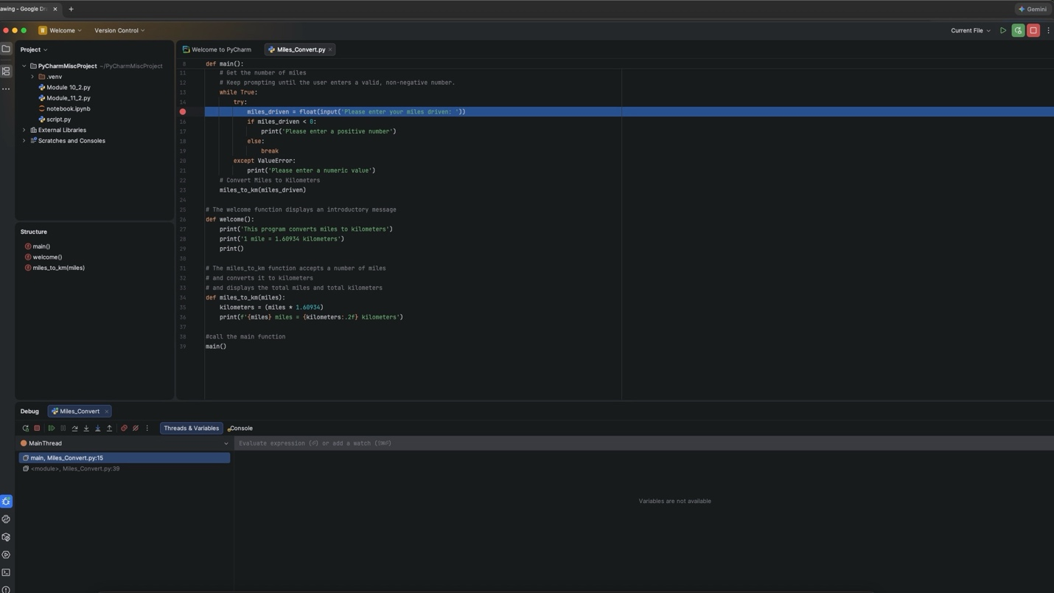
screenshot 1 shows the breakpoint set on the user input line and the debugger started in PyCharm.

Screenshot #2
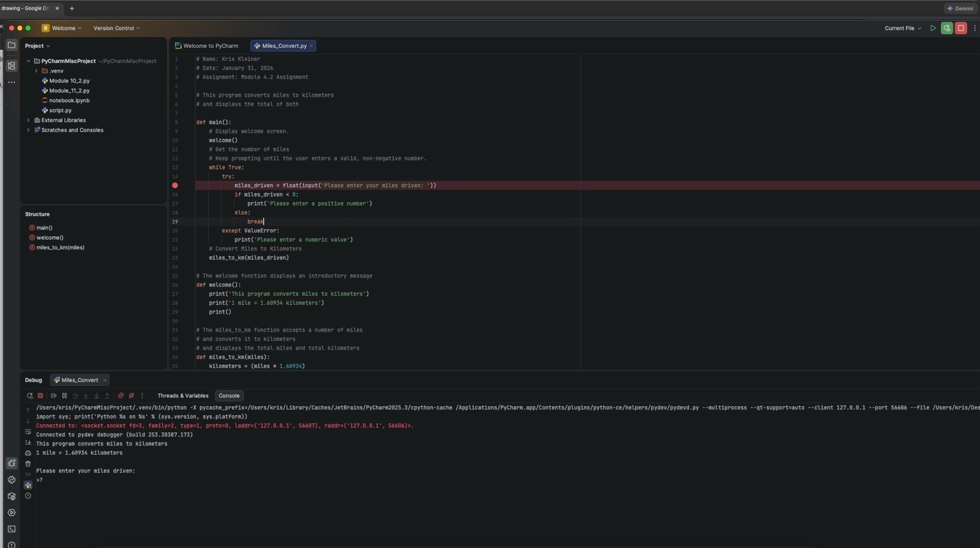
Screenshot 2 shows the program after resuming from the breakpoint and waiting for the user to enter input in the console.

Screenshot #3
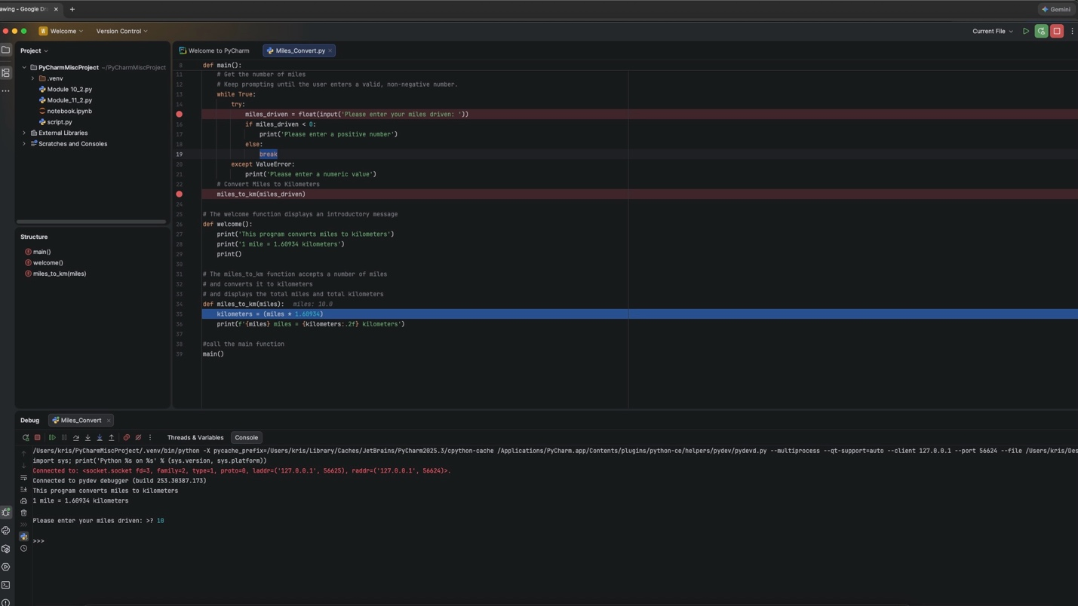
Screenshot 3 shows the debugger stepping into the miles_to_km function to observe how the program processes the user input.

